Misc

Vendor | Product | Description | Price | In Stock | Contact
Victory Innovations | 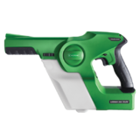 | VICTORY INNOVATIONS-VP200ESK Professional Cordless Electrostatic Handheld Sprayer | $699.99 | Out of Stock
Victory Innovations | 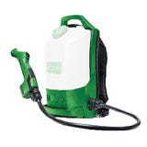 | VICTORY INNOVATIONS-VP300ES Professional Cordless Electrostatic Backpack Sprayer Kit | $1,749.99 | Out of Stock
Best Plumbing Specialties | 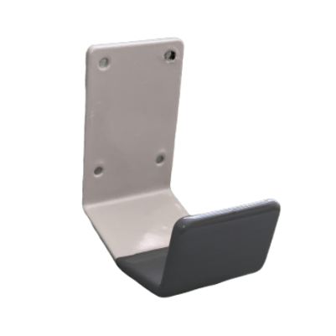 | Arm Door Pull Gray Antimicrobial Coating
Quill | Avalon 3-5 Gallon White Top Loading Hot & Cold Water Cooler Dispenser (A2TLWATERCOOLER)  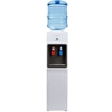 | 3 or 5 Gallon Bottle  11.25x10.75x42 inches  Hot & Cold Temp | $140.24
Quill | 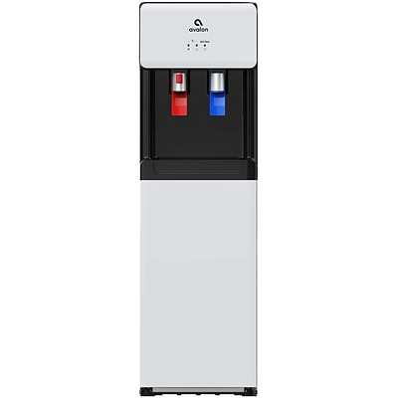  Avalon 3-5 Gallon White Bottom Loading Hot & Cold Water Cooler Dispenser (A6BLWTRCLRWHT) | Bottom loading water cooler dispenser  3 or 5 Gallon Bottle  13x12x41 inches | $233.74

